# User’s manual

Software accomplishment: user can use this software to manage their coupon information such as sorting, adding and searching.

**System Requirement:** applicable to every system with installed Java development environment(JDE).

**How to use:** After download this application you just doubly-click on this application and now you open this software, it will look like this:

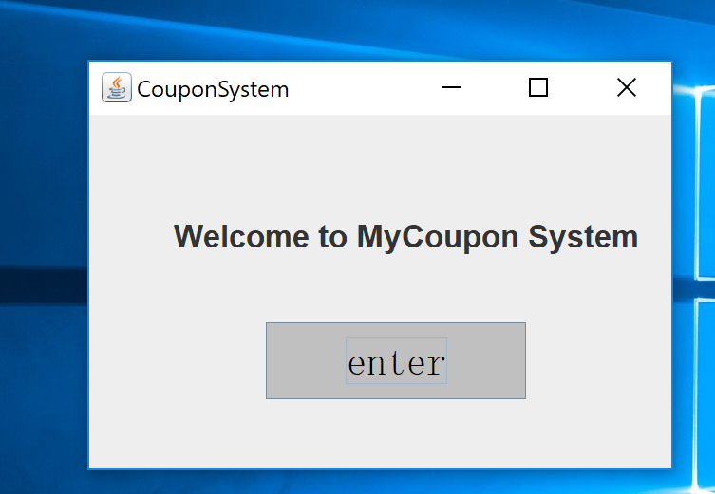

Then press ‘enter’ to enter into the main interface. You will see like this

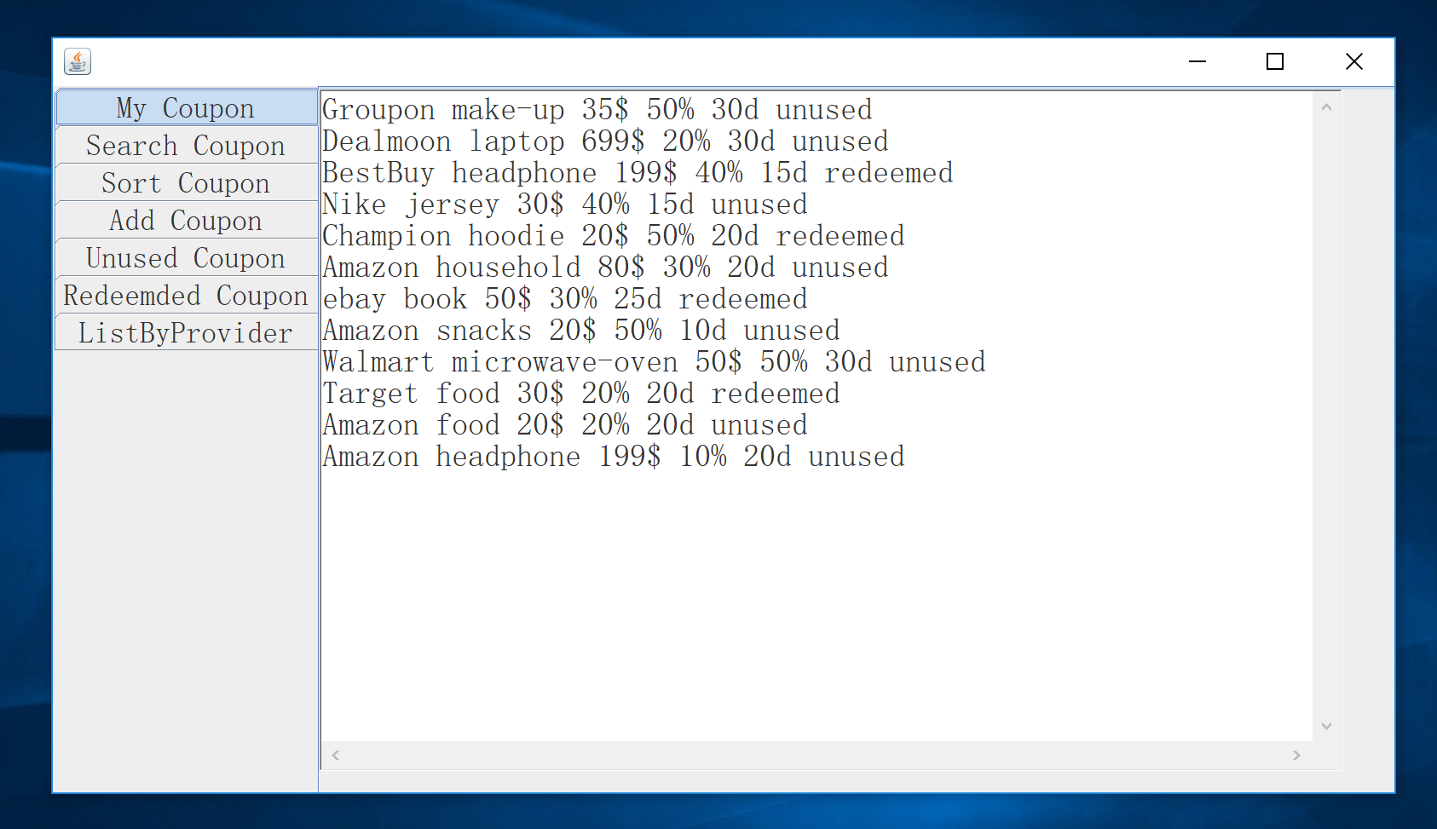

As you can see in the main interface there are 7 tags on left side, the first is user’s exsiting coupon. Second one is searching a specific coupon by product name:

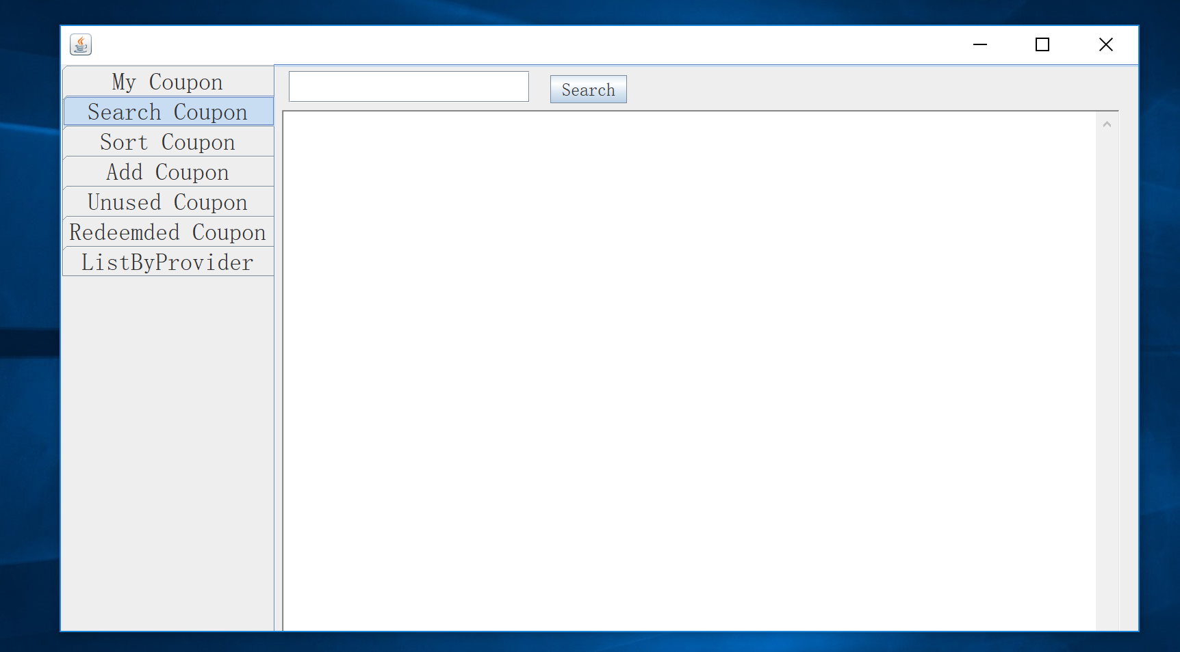

What you need to do is just type the product name into the textfiled and click ‘search’ and the result will show up in the textarea..

Third one is sorting coupon by final price in ascending order, looks like this:

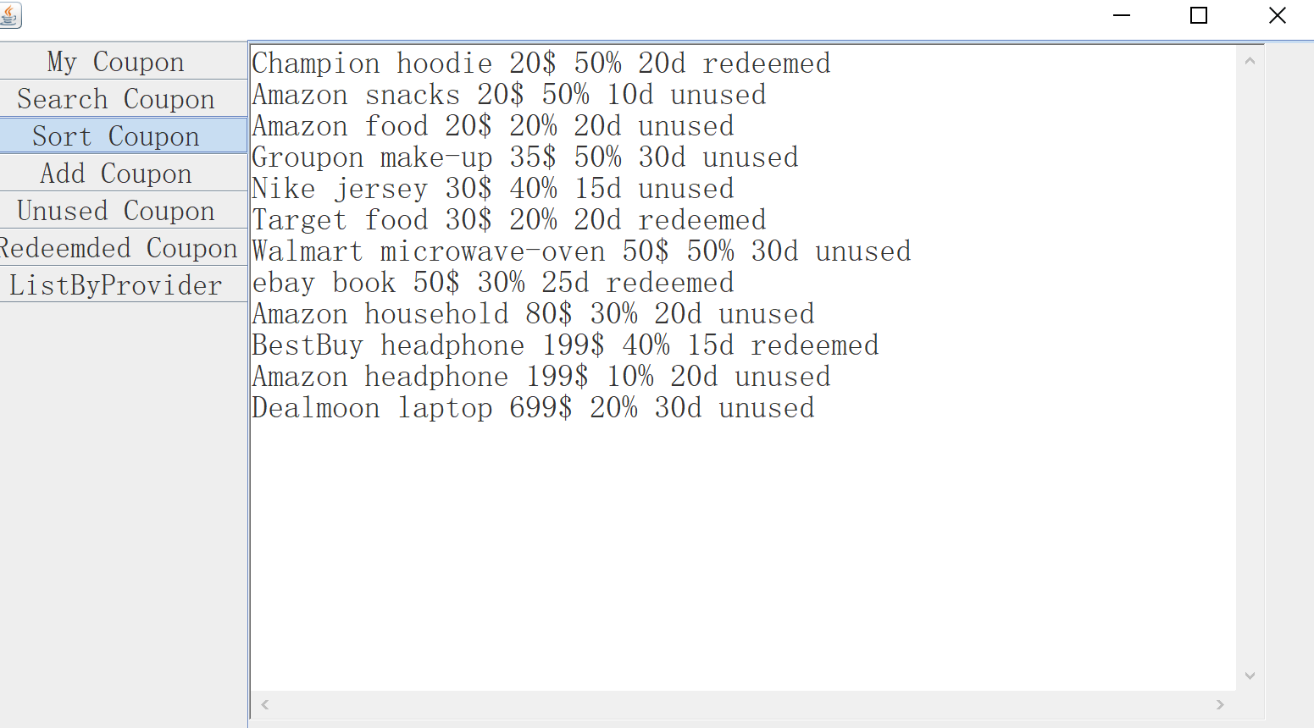

Next is adding coupon into you database:

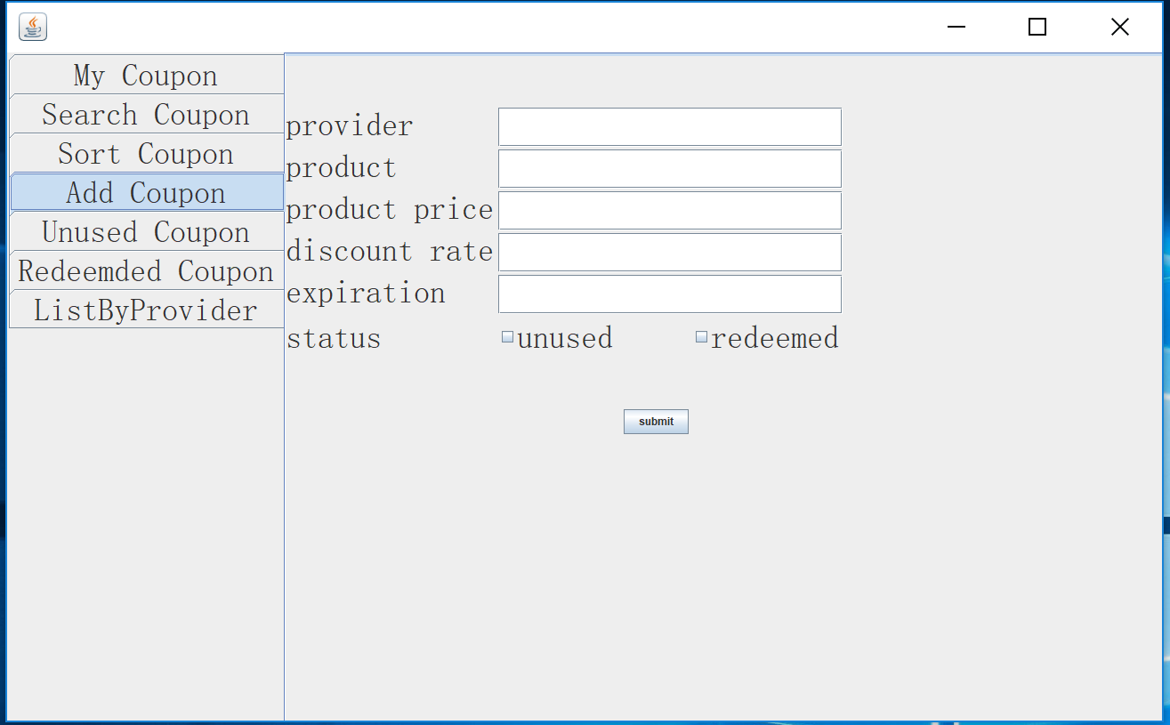

You need to input your coupon information by sequence; provider name, product name, product price, discount rate, expiration period, and choose status of your coupon just click each square. And then click on ‘submit’ you will see as follow:

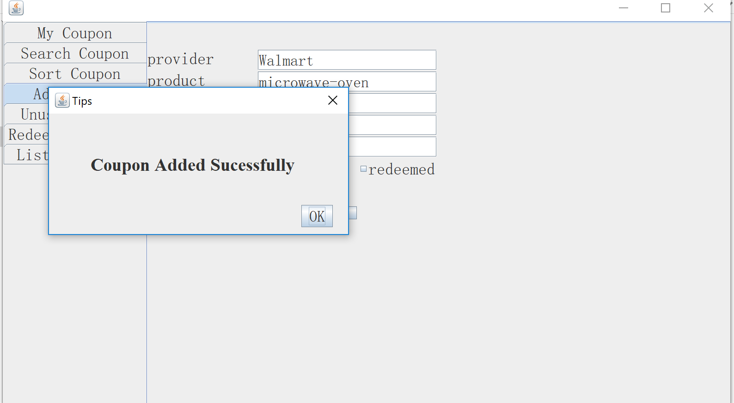

That means you have successfully insert you coupon into your database and you can see them in ‘My Coupon’ or use other function to get it.

In the next three menu, you can see your coupon which are unused, which are redeemed and sorted by provider name.

